Specifications

Part 1
1.2 Purpose
This document has been written by the software engineers in order to fully explain the functions of the earthquake tracker.It will explain the purpose and features of the system, the interfaces of the system, what the system will do, the constraints under which it must operate and how the system will react to external stimuli. This document is intended for both the users and the developers of the system

1.3. Scope of Project
This software system will be an earthquake tracker that displays all earthquakes in the last 30 days intended to be used by anyone interested in earthquakes in general.It will display the place,time and magnitude of the earthquake as well as a relevant url with information about it and a link of its location on google maps..

1.4 Glossary

Name | Other Name | Where | How | Contents | Limits
Earthquakes | None | Data Base | Database’s table | Earthquake occurrence | -
Id | None | Table “earthquakes” | Result | Int-The Id of each earthquake | -
Mag | Magnitude | Table “earthquakes” | Result | Float- The magnitude of each earthquake | -
Place | None | Table “earthquakes” | Result | Text- The place where each earthquake happened | -
Time | None | Table “earthquakes” | Result | bigint- When the earthquake happened | -
Url | More Details (only in website) | Table “earthquakes” | Result | Text-The Link that guides you to the USGS website | -
Longitude | None | Table “earthquakes” | Result | Float-The coordinates of each earthquake | -
Latitude | None | Table “earthquakes” | Result | Float- The coordinates of each earthquake | -
Depth | None | Table “earthquakes” | Result | Float- The distance that the center of the earthquake has from earth’s surface | -
Alert | None | Table “earthquakes” | Result | Text- A color that shows how dangerous the earthquake is | -

1.6 Overview
The next chapter, the Overall Description section, of this document gives an overview of the functionality of the product. It describes the informal requirements and is used to establish a context for the technical requirements specification in the next chapter.
The third chapter, Requirements Specification section, of this document is written primarily for the developers and describes in technical terms the details of the functionality of the product.

Part 2
2.1 System Diagram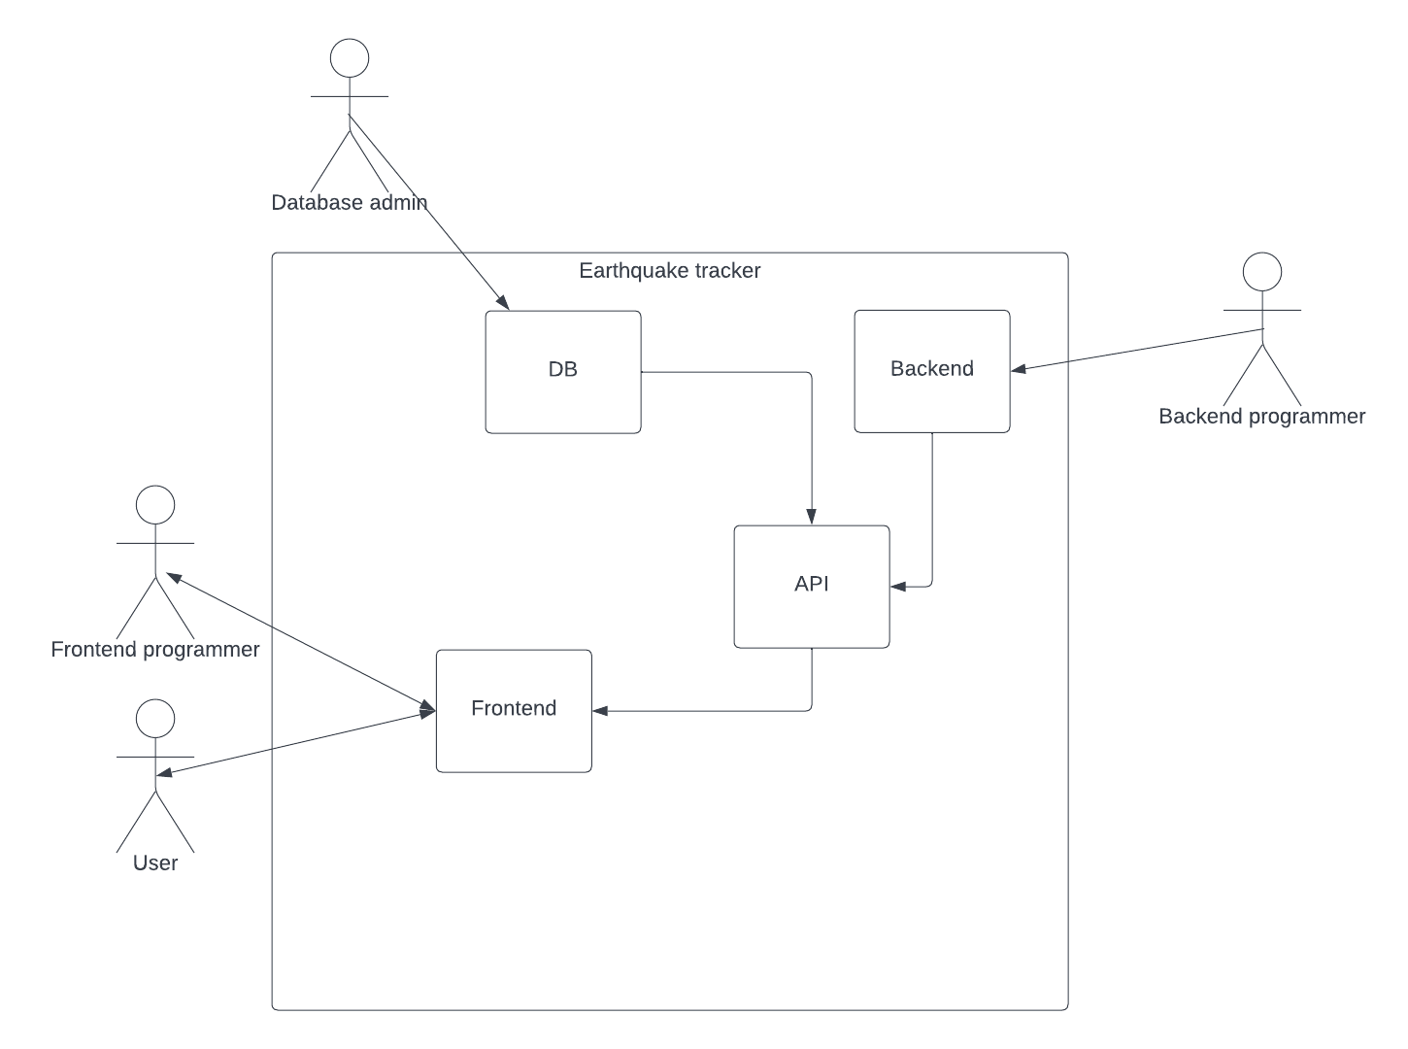

2.2 System environment

The earthquake tracker system has 4 actors and 4 cooperating systems.Our actors are the frontend programmer,the database admin and users while the cooperating systems are the database and api

2.3 Use Cases

2.3.1 User’s use case
Use case: Search Earthquake
Diagram:

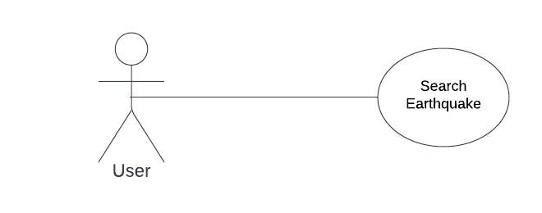

Brief Description
The user accesses our website, searches for an earthquake and learns some info about it.
Initial Step-By-Step Description
Before this use case can be initiated, the user has already accessed the website.

1. The user chooses to sort by magnitude,time or place.
2. The system displays the choices to the user.
3. The user selects the sorting method desired.
4. The system presents all earthquakes within the last 30 days,sorted in the way the user selected.
5. Then the user can navigate the tables by using the “next” and ”previous” buttons or the page number button.

2.3.2 Frontend Programmer’s uses cases
Use case: Alter the frontend of the website
Diagram:

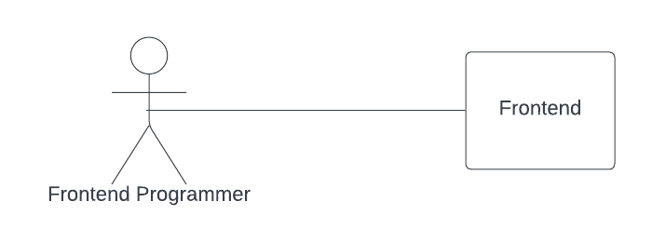
Brief Description
The programmer wants to make changes to the website, either aesthetic or functional.
Initial Step-By-Step Description
Before this use case can be initiated, the programmer has already accessed the frontend part.

1. The frontend programmer inspects the already existing code..
2. The frontend programmer chooses which lines he wants to make changes to.
3. The frontend programmer performs the changes.
4. Then he informs the rest of the team members about the changes and their potential impact to the rest of the system.
2.3.3 Backend Programmer’s uses cases
Use case: Alter the backend of the website in order to optimize it.
Diagram:
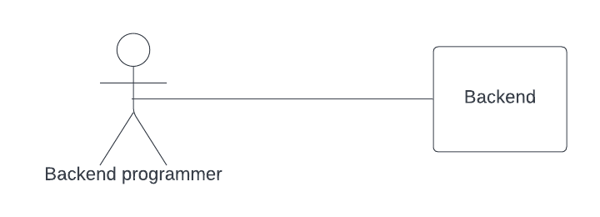

Brief Description
The backend programmer accesses the backend of the website in order to optimize code or perform maintenance.
Initial Step-By-Step Description
Before this use case can be initiated, the backend programmer has already accessed the website.

1. The backend programmer inspects the already existing code..
2. The backend programmer chooses which lines he wants to make changes to.
3. The backend programmer performs the changes.
4. Then he informs the rest of the team members about the changes and their potential impact to the rest of the system.

2.3.3 Backend Programmer’s uses cases
Use case: Alter things at the database in which the information is stored.
Diagram:

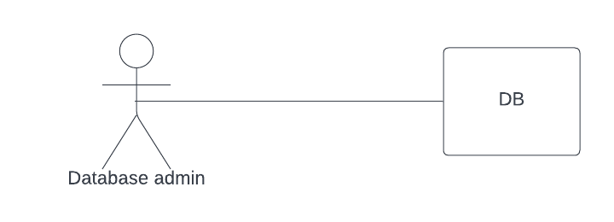Brief Description
The Database admin accesses the database in order to optimize code or perform maintenance.
Initial Step-By-Step Description
Before this use case can be initiated, the Database admin has already accessed the database.

1. The Database admin inspects the already existing code..
2. The Database admin chooses which lines he wants to make changes to.
3. The Database admin performs the changes.
4. Then he informs the rest of the team members about the changes and their potential impact to the rest of the system.

2.4 User Characteristics
The programmers are expected to be Internet literate as well as proficient in HTML and Python.They will be the ones making changes to the back end,front end and the database.

The user is expected to be Internet literate and be able to use a search engine. The main screen of the earthquake tracker will have a table containing the time,place and magnitude of each earthquake as well as a relevant link,the user is expected to be able to manipulate this table in order to find the earthquake he was searching for.

2.5 Non-Functional Requirements
The earthquake tracker will draw information from an api at https://earthquake.usgs.gov/earthquakes/feed/v1.0/geojson.php#earthquakes . Connection between the Database and the web page will be achieved using the Postman app or an equivalent.The speed of the User’s connection will depend on the hardware used rather than characteristics of this system.

Part 3
3.0. Requirements Specification
3.1 External Interface Requirements
The only link to another website is when the user wants more information about an earthquake. When the user thinks that he wants more information he can click on the button “more Details” and then “more info” and he can search on the website USGS. There he can find more details about Earth-system interactions that happen in different places and help him (the user) continue his search in depth.
Also, the user has the ability to see the place that the earthquake took place in google maps by clicking on the link. The user can find the link in the same place he can find the link of the USGS page.
3.2 Functional Requirements
3.2.1 HOME Button
Use Case Name | Home Button
XRef | Section 2.2.1, Home Button
Trigger | User wants to be transferred to the home page
Precondition | User should be in another page of the website
Basic Paths | 1. User decides if he wants to go to the home page.  2. User clicks the Home button
Alternative Paths | None
Postcondition | User is in the home page
Exception Paths | None
Other | None

3.2.2 TABLE Button
Use Case Name | Table Button
XRef | Section 2.2.2, Table Button
Trigger | User wants to be transferred in the main page
Precondition | User should be in the home page of the website
Basic Paths | 3. User decides if he wants to go to the main page.  4. User clicks the TABLE button
Alternative Paths | None
Postcondition | User is in the main page
Exception Paths | None
Other | None

3.2.3 ABOUT Button
Use Case Name | About Button
XRef | Section 2.2.3, Home
Trigger | User wants to learn more about our team

Precondition | User should be in the home or main page of the website
Basic Paths | 1. User decides if he wants to learn details about our team.  2. User clicks the ABOUT button
Alternative Paths | None
Postcondition | User is on the “get to know us” page.
Exception Paths | None
Other | None

3.2.4 First earthquake of the list
Use Case Name | First earthquake of the list
XRef | Section 2.2.4, First earthquake of the list
Trigger | The User wants to see the first earthquake
Precondition | The User has to be in the homepage
Basic Path | 1. The User decides to see the first earthquake  2. The User should click on the link in the blue framework  3. It will display the first earthquake on the user’s screen.  4. If the user wants to see the next earthquake, then he should click on the button “next”  5. Otherwise, if he wants to go to the previous earthquake he should click on the button “previous”. (This feature is not available to the user if he is viewing the first earthquake)
Alternative Paths | 1. The user can click the TABLE button 2. The user can sort each earthquake by place or magnitude or time .
Postcondition | The user can see the first earthquake
Exception Paths | None
Other | None

3.2.5 Search an earthquake
Use Case Name | Search Earthquake
XRef | Section 2.2.5, Search Earthquake
Trigger | The user tries to find an earthquake. The user has to click on the table button.
Precondition | The Web is displayed with grids/bars for searching

Basic Path | 1. The user decides how he wants to search for the earthquake. He can sort them by magnitude, time or place.  2. If the user decides to sort by place, the system will automatically present a list of any of the earthquakes that exist in the database with the time they happened and their magnitude,  according to the sorting the user used or the one that already existed. For example, the earthquakes can be shown from highest ID to lowest or from lowest to highest. Also, the website can present the earthquakes in alphabetical order.  3. The user can select one of the earthquakes he is interested in and click on “more Details” to find more details or information.  4. After that the website will present another list with details about the earthquake  5. The user can click on the “more info” link if he wants to be transferred to another website (USGS) and find more details on other geological interactions about that location.  6. Also, the user can click the associated link in google maps if he wants to see the location at which the earthquake took place.
Alternative Paths | In step 2 the user selects to sort by the time an earthquake happened:  1. Then the website will automatically present a list of the earthquakes with the date they happened and their magnitude,  according to the sorting the user used before or already existed.  2. The user can select one of the earthquakes he is interested in and push “more Details” to find more details or information  3. After that the system will present another list with details about the earthquake  4. The user can click “more info” if he wants to be transferred to another website (USGS) and find more details about other geological  interactions about this place.  5. Also, the user can click on the link in google maps if he wants to see the place where the earthquake took place.  In step 2 the user selects to search by the magnitude of the earthquake:  1. Then the system will present automatically again the same list with the earthquakes with the time they become and their magnitude,

according to the sorting the user did before or already existed.
2. The user can select one of the earthquakes he interests and push “more Details” to find more details or information
3. After that the system will present another list with details about the earthquake
4. The user can click on “more info” If he wants to be transferred in another system (USGS) and find more details about other geological
interactions about this place.
5. Also, the user can click the link in google maps if he wants to see the place where the earthquake took place.
Postcondition | The user has found the necessary information and details he needed
Exception Paths | The User may abandon the search at any time.
Others | The categories list is a predefined database.

3.2.6 Sorting
Use Case Name | Sorting earthquakes
XRef | Section 2.2.6, Sorting earthquake
Trigger | The user wants to sort the results based on his interests
Precondition | User is on the website
Basic Path | 1. The user decides how he wants the system to sort the results. He can sort the earthquakes by ID,  magnitude, place or time of the earthquake.  2. If the user decides to sort the results by ID, then he should select the ID row and click on it. When he  searches for an earthquake the results will be a list of the earthquakes sorted by their IDs. So the earthquake with the biggest ID will be first in the final list.  3. If the user has already searched for a specific earthquake the final list will automatically change and the earthquakes will be sorted from the highest ID number to the lowest
Alternative Paths | In step 2 the user decides the final list of results to be sorted by time.  1. They should sort by time, select and left click the time bar. When he searches for an earthquake the results will be a list of all earthquakes with the most recent time that each earthquake took place.  2. If the user has already searched for an earthquake the final list will automatically change and the earthquakes will be sorted based on the time that they happened.

In step 2 the user decides the final list of results to be sorted by the magnitude of each earthquake
1. He should go to the magnitude (bar), select and left click the magnitude bar. When he searches an
earthquake the results will be a list of earthquakes sorted by the size of their magnitude. So the first earthquake will be him with the biggest magnitude
2. If the user has already searched the earthquake the final list will automatically change and the
earthquakes will be sorted based on the magnitude they happened.
In step 2 the user decides the final list of the results to be sorted by the place that each earthquake happened: 1. Then they should go to the place (bar) , select it and click on the place bar. When he searches for an earthquake the results will be a list of earthquakes sorted by the nearest place each earthquake has taken place. 2. If the user has already searched for an earthquake the final list will automatically change and the earthquakes will be sorted based on their distance from local areas .
Postcondition | A list of all earthquakes is shown on the screen, sorted according to the user's choices.
Exception Paths | User does not want to sort the list of earthquakes.
Other | None

3.2.7 Show number of earthquakes
Use Case Name | Show number of earthquakes
XRef | Section 2.2.7, Show number of earthquake
Trigger | The user wants to regulate the size of the list so that it displays a certain amount of earthquakes
Precondition | User already has a list of earthquakes on his screen or he already has searched some earthquakes before
Basic Path | 1. The user decides how many earthquakes he wants his list to have. He can choose between 10,25,50 or 100 earthquakes.  2. If the user decides on 10 earthquakes, then he should click on the “show” bar and click on the number 10. Then the number of earthquakes in his list will be 10.
Alternative  Paths | In step 2 the user decides the final number of the earthquakes will be 25 :  1. Then he should click on the “show” bar and click on the number 25. Then the number of earthquakes in his list will be 25.

In step 2 the user decides the final number of the earthquakes will be 50 :
1. Then he should click on the “show” bar and click on the number 50. Then the number of earthquakes in his list will be 50.
In step 2 the user decides the final number of the earthquakes be 100 :
1. Then he should click on the “show” bar and click on the number 100. Then the number of the earthquakes in his list will be 100.
Postcondition | The list will have the number of earthquakes the user has chosen
Exception Paths | None
Other | None

3.2.8 Buttons of the website’s pages
Use Case Name | Button of the website’s pages
XRef | Section 2.2.8, Button of the website’s pages
Trigger | The user wants to see more earthquakes
Precondition | The user has selected to be shown a number of earthquakes.
Basic Path | 1. The user decides if he wants to go to the next page, previous page or to another page on the website.  2. The user decides to go to the next page on the website.  3. He should click on the button “Next” so that he can get to the next page and see the rest of the earthquakes that are in the list
Alternative Paths | In step 2 user decides to go to the previous page on the website:  i. He should click on the button “Previous” so that he can get to the previous page and see the previous earthquakes that are on the list.  In step 2 the user decides to go to the n-page in the website: 1. He should click on the button with the n-page so he can get to the n-page and see the  earthquakes that are on the list in that page.
Postcondition | User will be on the page he wants and find his desired earthquake.
Exception Paths | 1. If the user is on the first page of our website, then he cannot go to the previous page, because it does not exist. He can go only to the next or another page in the website.  2. Τhe number of pages depends on the number chosen by the user in the previous use case.
Other | None

3.2.9 Replace Earthquakes
Use Case Name | Replace Earthquakes
XRef | Section 2.2.9, Replace earthquakes
Trigger | The backend programmer wants to replace all the earthquakes
Precondition | There are earthquakes in the source url already.
Basic Path | 1. The backend programmer decides if he wants to replace all the earthquakes with new earthquakes.  2. The backend programmer copies and pastes the link in the Source url bar.  3. Then the backend programmer should click on the button “Replace” so that the new earthquakes replace all the old ones.
Alternative Paths | 1. The backend programmer should copy all the data.  2. Paste them in the text frame.  3. Then the backend programmer should click on the button “Replace” so that the new earthquakes replace all the old ones.
Postcondition | The old list of the earthquakes will be replaced with the new one.
Exception Paths | None
Other | None

3.2.9 Add new Earthquakes

Use Case Name | Add new Earthquakes
XRef | Section 2.2.10, Add new earthquakes
Trigger | The backend programmer wants to add new earthquakes
Precondition | There are earthquakes in the source url already(It’s not necessary).
Basic Path | 1. The backend programmer decides if he wants to add new earthquakes on the website.  2. The backend programmer copies and pastes the link in the Source url bar.  3. Then the backend programmer should click on the button “Add new” so the new earthquakes are added to the website. If some of them are the same they will not be changed.
Alternative Paths | 1. The backend programmer should copy all the data .  2. Then the backend programmer should paste them in the text frame.  3. Then the backend programmer should click on the button “Add new” so the new earthquakes will be added to the website. If some of them are identical they will not be changed
Postcondition | A new list of the earthquakes will be created.
Exception Paths | None
Other | None

3.2.10 Add Earthquakes
Use Case Name | Add Earthquakes
XRef | Section 2.2.11, Add earthquakes
Trigger | The backend programmer wants to add more earthquakes
Precondition | The earthquakes he wanted are not listed (Not necessary)
Basic Path | 1. The backend programmer decides if he wants to add earthquakes on the website.  2. The backend programmer copies and pastes the link in the source url bar.  3. Then the client should click on the button “Add ” so that the earthquakes can be added to the website.If some of them are identical they will be changed.
Alternative Paths | 1. The backend programmer should copy all the data.  2. Then the backend programmer should paste them in the text frame.  3. Then the backend programmer should click on the button “Add ” so that the earthquakes can be added to the website.If some of them are identical they will be changed.
Postcondition | A list of all the earthquakes is created.
Exception Paths | None
Other | None

